

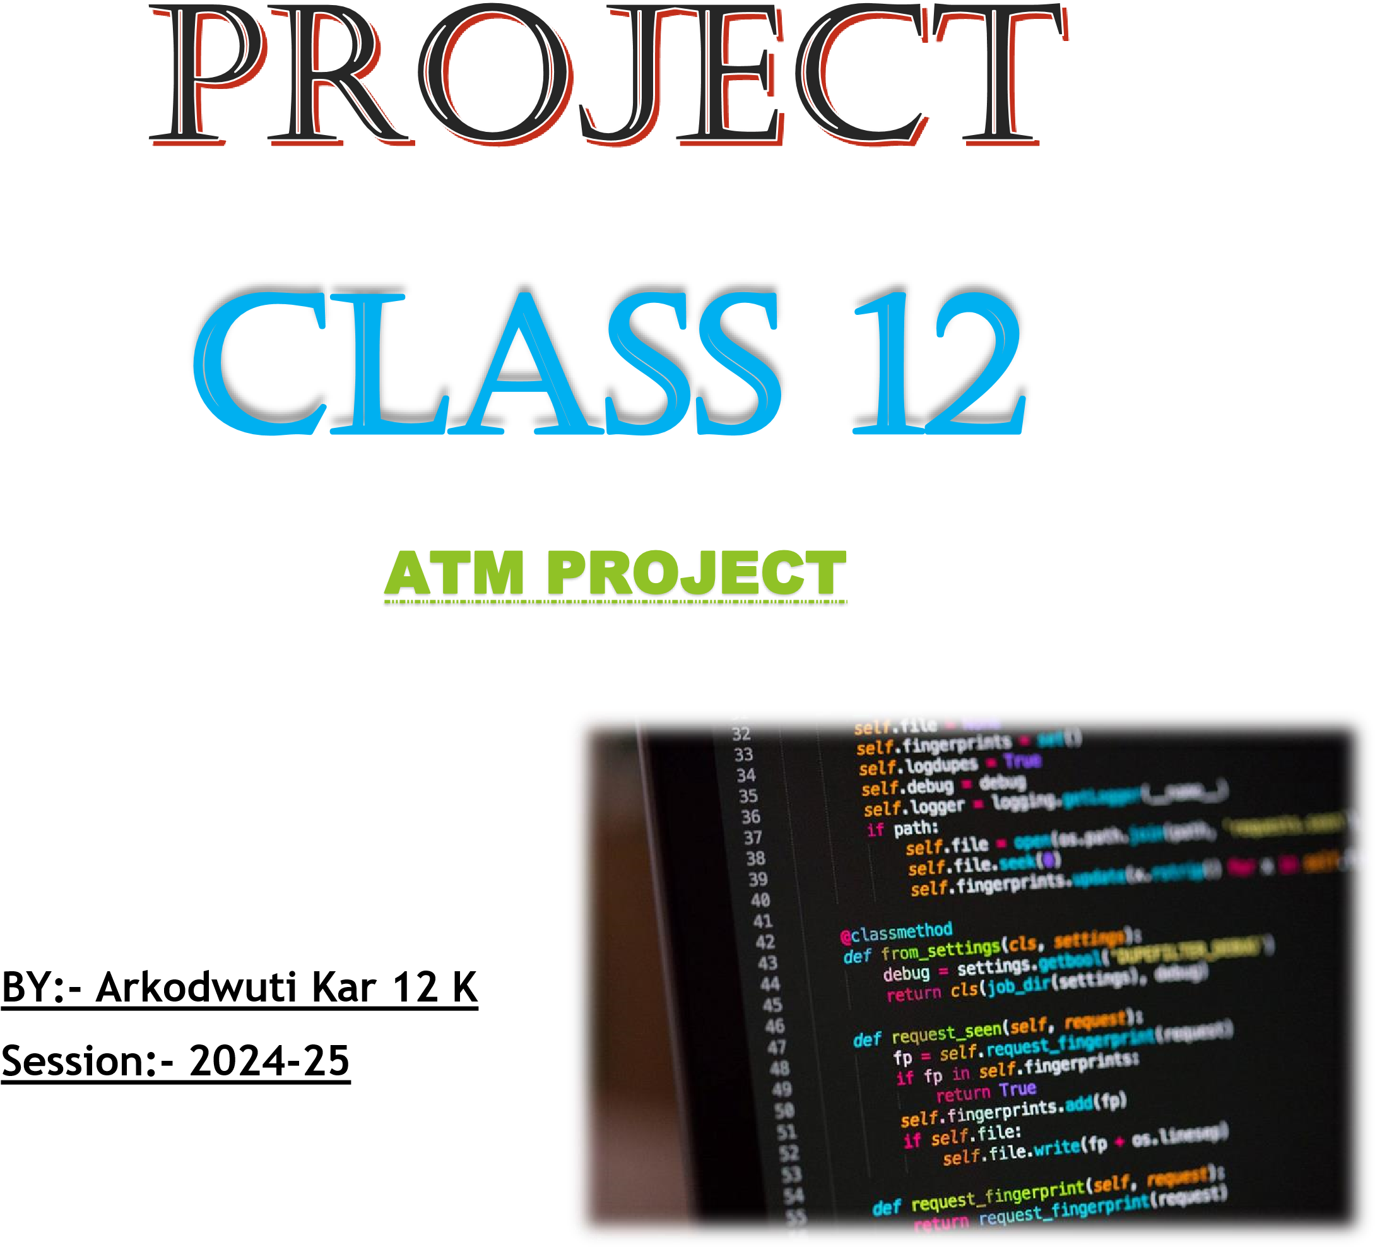

**NAME- ARYA MANDAL  
CLASS- 12 SEC- K  
ROLL NO- 18**

PROGRAM:-

import time

import mysql.connector as msc

w1=msc.connect(host="localhost",user="root",passwd="acfa@123",database="r2")

cur=w1.cursor()

def balance():

while True:

n1=int(input("Enter your id: "))

n2=input("Enter your password: ")

try:

Q=f"select * from balance where id={n1} and password='{n2}'"

cur.execute(Q)

result=cur.fetchone()

if not result:

raise ValueError("Invalid Id or password")

except:

print("Password or id inccorect :(")

n3=input("Retry(R) or Exit(E)?\n>>").upper()

if n3!="R":

break

else:

n4=input("Sure? ").lower()

if n4=="y":

break

print(result)

def deposit():

n1=int(input("Enter your id: "))

n2=input("Enter your password: ")

n3=int(input("Enter the amount deposited: "))

try:

Q=f"select * from balance where id={n1} and password='{n2}'"

cur.execute(Q)

result=cur.fetchone()

if not result:

raise ValueError("Invalid Id or password")

except:

print("Password or id inccorect :(")

else:

Q=f"update balance set balance = {n3}+balance where id={n1}"

cur.execute(Q)

w1.commit()

print("Thanks for depositing :)!")

def withdraw():

n1=int(input("Enter your id: "))

n2=input("Enter your password: ")

n3=int(input("Enter your amount: "))

try:

Q=f"select * from balance where id={n1} and password='{n2}'"

cur.execute(Q)

result=cur.fetchone()

if not result:

raise ValueError("Invalid Id or password")

except:

print("Password or id inccorect :(")

else:

Q=f"update balance set balance = balance-{n3} where id={n1}"

cur.execute(Q)

w1.commit()

print(f"{n3} amount withdrawed!! Thank You :)")

def forgot_password():

n1=int(input("Enter your id: "))

n2=input("Enter unique code: ")

try:

Q=f"select * from balance where id={n1} and code='{n2}'"

cur.execute(Q)

result=cur.fetchone()

if not result:

raise ValueError("Invalid Id or password")

except:

print("Password or id inccorect :(")

else:

n3=input("enter the new password: ")

Q=f"update balance set password='{n3}' where id={n1}"

cur.execute(Q)

w1.commit()

print("Password changed succesfully")

def welcome_message():

card_id = input("Enter your unique Card ID: ")

if card_id:

print("searching your account....")

time.sleep(3)

print(f"Welcome, User {card_id}!")

else:

print("Card ID cannot be empty. Please try again.")

welcome_message()

while True:

u1=input("""

1) view balance

2) withdraw

3) Deposit

4) Forgot password

5) Cancel

>>> """)

if u1=="1":

balance()

elif u1=="2":

withdraw()

elif u1=="3":

deposit()

elif u1=="4":

forgot_password()

elif u1=="5":

break